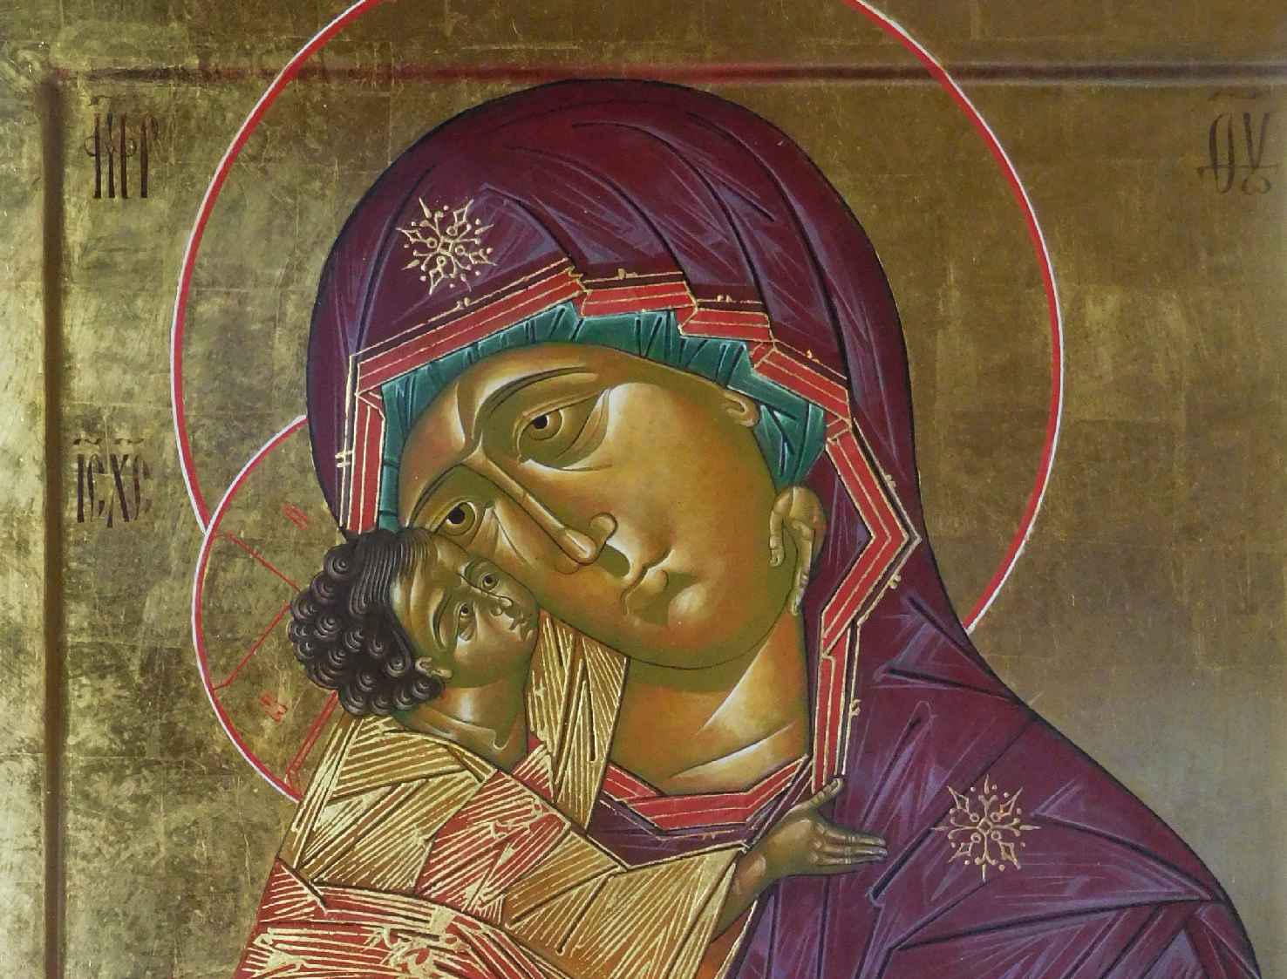


An exploration
and an experience
Sacred Silence in Literature and the Arts Conference 2019

Friday 4 – Saturday 5 October 2019
Gleeson Auditorium, Australian Catholic University, 25A Barker Road, Strathfield, NSW 2135
This conference is a coming together of artists, writers, musicians, academics and practitioners of the sacred from different faith and no-faith traditions.

1

Welcome to the tenth Sacred Silence in Literature and the Arts (SLA) Conference front image art work by Leonard Brown
2019 presenters and presentations

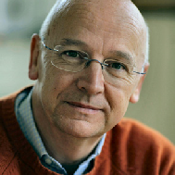
Laurence Freeman OSB
Father Freeman was a keynote speaker at the 2017 SLA Conference, Awakening the Sacred. He is a Benedictine monk of the Congregation of Monte Oliveto and also Director of the World Community for Christian Meditation and of its Benedictine Oblate community.
Father Freeman is the author of many books, including Light Within, Selfless Self, Your Daily Practice, The Inner Pilgrimage, Jesus: The Teacher Within and First Sight: The Experience of Faith.
Strongly committed to inter-religious dialogue and global peace initiatives, he has co-led with the Dalai Lama at regular events in the historic Way of Peace program. He has been made an Officer of the Order of Canada for his work for peace. He is also Director of the newly opened Bonnevaux Centre for Peace near Poitiers in France, where he resides and participates in a broad programme of meditation retreats and dialogue supporting peace-building and mutual understanding. Father Freeman is also a graduate in English Literature from Oxford University with a deep interest in the sacred dimension of literature and art.
Presentation: Silence in the Russian/American artist Mark Rothko (1903–1970). Father Freeman will also lead the conference community in silent meditation.

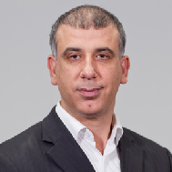
Associate Professor Mehmet Ozalp
Ozalp is a prominent Muslim community leader in Australia. He is a scholar, public intellectual and community leader. He is an Associate Professor of Islamic studies and the Director of the Centre for Islamic Studies and Civilisation (CISAC) which he founded at Charles Sturt University (CSU). He is also the founder and Executive Director of (Islamic Sciences and Research Academy of Australia)
ISRA. Under his leadership, CISAC and ISRA pioneered Islamic Studies courses at undergraduate and postgraduate level since 2011.
Ozalp is the editor-in-chief of the Australian Journal of Islamic Studies. He serves on the executive committee of the strategic research centre Public and Contextual Theology (PaCT) linked to CSU. He serves on the Human Research Ethics Committee at the University of Sydney. Ozalp has been serving as the Muslim Chaplain at the University of Sydney and the Macquarie University since 2006. Ozalp’s
publications include these three books: 101 Questions You Asked About Islam, Islam in the Modern World and Islam between Tradition and Modernity: An Australian Perspective.
Presentation: In Dialogue with Laurence Freeman on Silence and Wellbeing.

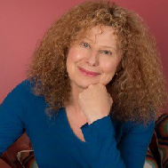
Rachael Kohn
Kohn is a former ABC radio broadcaster responsible for the program, The Spirit of Things. She was awarded a Doctor of Letters from the University of New South Wales in 2005 for services to community fostering religious understanding through her broadcasts, public speaking and book entitled The
New Believers: Re-imagining God. She has won three world gold medals from the New York Festivals International Radio Competition.
Presentation: Kohn will open the conference with reflections on ‘Silence’ in the context of her own Jewish faith tradition.

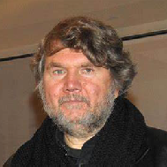
Professor Sasha Grishin AM, FAHA
Emeritus Professor of Art History, Grishin works internationally as an art historian, art critic and curator. He studied at universities in Melbourne, Moscow, London and Oxford and has served as visiting scholar at Harvard University. In 2014 his Australian Art: A History was published by Melbourne University Publishing.
Presentation: Spirituality and the Russian avant-garde. Professor Grishin examines the links between the early 20th century Russian avant-garde artists and the Russian spiritual tradition inherent in medieval icons.

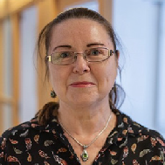
Professor Carole M. Cusack
Cusack, a Professor of Religious Studies at the University of Sydney, trained as a medievalist. She has a doctorate published as Conversion Among the Germanic Peoples (Cassell 1998) and now researches contemporary religious trends. Her books include Anime with Katharine Buljan, Religion and
Spirituality: Profane and Sacred Worlds in Contemporary Japan (Equinox 2015) and The Sacred Tree: Ancient and Medieval Manifestations (Cambridge Scholars Publishing 2011).
Presentation: The Multiple Silences of Julian of Norwich (c. 1342–c.1416). This lecture explores the paradoxical silences in the life and work of Julian of Norwich. Julian’s visions focused on ideas of sin, salvation and punishment, and gained popularity due to the optimistic words attributed to Christ: “All shall be well, and all manner of thing shall be well.”

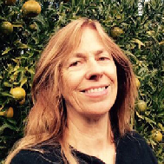
Dr Susan Murphy
Murphy is a Zen Roshi and runs regular seven-day Zen retreats. She is the founding teacher of Zen Open Circle and the author of three volumes on Zen: Upside-Down Zen; Minding the Earth, Mending the World; Red Thread Zen. She is also a prize-winning film writer-director and a regular freelance producer of feature documentaries for ABC Radio National.
Presentation: Seven forms of silence in Zen awakening. The famous 8th century Song of Freedom (‘Zhengdaoge’ in Chinese,Shodoka in Japanese) attributed to Yongjia Xuanjue tells us that “It speaks in silence; In speech, you hear its silence”. ‘It’ is unnamed here the way that God is left unnamed, being too limitless for words to contain. Nothing is left out of it, and this fullness of reality has no outside.

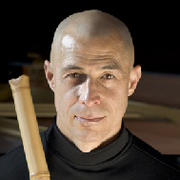
Riley Lee
Lee began studying the shakuhachi in 1971 in Japan and became the first non-Japanese officially acknowledged as a shakuhachi Dai Shihan (Grand Master). He has a PhD in musicology from Sydney University and has released over 60 albums, with over 150,000 monthly listeners on Spotify.
In 2018, he designed and taught a course on meditation, the mind, memory and music at Princeton University. Each year Riley gives performances, workshops, and lectures in Australia, USA and Europe. Visit: www.rileylee.net
Presentation: Sound in silence. When playing the so-called “original pieces” (honkyoku) for the shakuhachi, much importance is placed on what many would call the silence between the music. Lee will attempt to share his understanding of the “silence” in shakuhachi honkyoku.- in the Barron Memorial Chapel

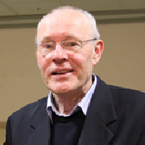
Father Michael Whelan
Father Michael is director of the Aquinas Academy adult education centre and parish priest of St Patrick’s, Church Hill in Sydney.
Presentation: Silence speaks truthfully. Hans Kung, in his little book on Mozart (Mozart: Traces of Transcendence), quotes the German sociologist, philosopher and musicologist, Theodor Adorno, “When I hear great music, I believe that I know that what this music says cannot be untrue.” Silence may be understood as an event. This is hugely paradoxical as silence seems more like absence than presence.
Silence is absence in service of presence. Silence speaks – it cannot be untrue.

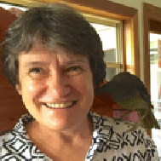
Judith Beveridge
Beveridge has won prizes including the Philip Hodgins Memorial Medal and the Christopher Brennan Award for lifetime achievement in literature. She published seven collections of poetry, most recently Sun Music: New and Selected Poems.
Presentation: Poetry and sacred silence. Beveridge will explore how poetry, because of its unique uses of language, can be used as a tool to approach the divine. She will explore the specific devices of imagery, rhythm and sound and show how these become interwoven into a highly concentrated expression which reverberates into and animates our consciousness. Poetic concentration is a pathway into truth, it uncovers connection and interrelationships which enhance our experience of the world. She will explore how poetry awakens us to the many possibilities of being.

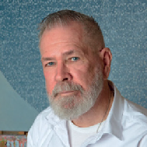
Leonard Brown
Brown is an Australian artist who works on both canonical icons and contemporary painting. There is a concurrent exhibition of his work during the conference.
Presentation:“That there is a God is clear; but what He is by essence and nature, this is altogether beyond our comprehension and knowledge” – St John of Damascus.
My dual activities, of canonical icon and contemporary painting, are both moderated within a milieu of an Apophatic Theology, approaching the Divine, by negation, navigating in terms of what may not be said about the perfect goodness that is God.

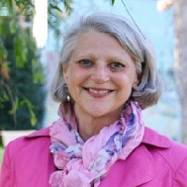
Debra Phillips
Phillips is a PhD candidate at ACU. Her interdisciplinary PhD by creative project examines the interconnections between narrative, imagination, future, spirituality, and the visual arts in relationship to suicidality. Phillips’ academic writing and presentations refer to textual and visual narratives of the imagined future.
Presentation: Silence as the ‘sacre coèur’ of art-making.

Dr Jennifer Carpenter
Dr Carpenter is Deputy Head of School of Arts at ACU.
Presentation: Negotiating silence and silences in the 13th century: The power and meaning of silence in hagiographical texts from the Low Countries. Dr Carpenter focuses on a unique corpus of 13th century texts from the Low Countries that record the lives of local, contemporary, holy women (mostly) and men, including laywomen, recluses, monks and nuns, early beguines and hospital sisters. The paper
will consider the power and meaning of silence in these texts – silence practised in relation to monastic tradition, silence and speech in relation to the assertion of mystical authority, and the silences of texts written to shape and advocate for new and sometimes unsettling religious experience.

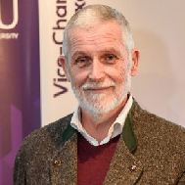
Dr Michael Griffith
Griffith is an Associate Professor of Literature at ACU. He is founder of the Religion, Literature and the Arts Movement in Sydney in the 1990s and author of God’s Fool: The Life and Poetry of Francis Webb, winner of a Human Rights Award in 1991.
Presentation: Silence and the Australian spiritual imagination. I have had a long standing interest in the way that poets, novelists and Australian artists explore the theme and experience of silence as a touch-stone for their deepest search. “Words reach into the silence,” T.S. Eliot.

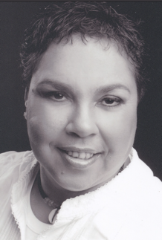
Theresa Ardler:
Theresa Ardler is a Gweagal Aboriginal woman. She is the Research Indigenous Liaison Officer at the Institute for Positive Psychology & Education at Australian Catholic University.Theresa’s working life has been in education. Theresa’s vision is to work towards educating school communities, teachers, students and universities about the richness of Aboriginal Culture and Spirituality within Australian society. As the future of Aboriginal education unfolds Theresa seeks opportunities to work creatively and innovatively in cultural and school/university environments that can produce genuine and meaningful cultural dialogue. In September 2017 Theresa was awarded “The ‘New Indigenous Voice’ in Educational Leadership”. In November 2017 Theresa was awarded, NSW Branch of the Australian College of Educators – “World Teachers’ Day 2017: Certificate of Recognition for outstanding contribution to the teaching profession”.

Presentation: Welcome to Country and Spiritual listening and connection to Country and Sea.

Juno Gemes
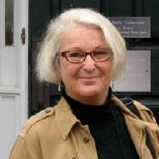
Juno Gemes is one of Australia’s most notable photographers, documenting the changing social landscape of Australia. On the 25 November 1985 Juno was invited to photograph the historic Uluru Handback Ceremony. In 2010, Juno was invited back to photograph the 25th Anniversary of the Handback Ceremony. Juno records the lives and struggles of Aboriginal Australians, a process that culminated in her being selected in 2008 as one of ten photographers invited to document the National Apology in Canberra. With her partner, the renowned Australian poet Robert Adamson she has collaborated on books and editorial projects. In their joint publication The Language of Oysters (Poems by Robert Adamson, Photographs by Juno Gemes) Robert writes:
“Calling for expression as we approach silence.
Our words are bright with countless lives” The Ribbon Fish.
The image captures the intertwining of the photographer’s art of silence and the kinetic energy of the poet’s words. Both Juno and Robert are committed to the enactive silence that embodies vibrant life.
Her work Terra Ancien/Terra Nova 2005 was a finalist in the Blake Prize of that year. This includes: Arrival / Fugitive Lovers / Annunciation- Strength / Bush Madonna / In Winter. These images project icons that evoke WEH Stanners “The Great Australian Silence”; they are mesmerising in their evocation of place and history.

Presentation: An introduction to Terra Ancien/ Terra Nova hung in the Quiet Room Chapel (601)

Robert Adamson
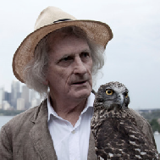
Robert Adamson grew up in Neutral Bay. As a juvenile delinquent, he often sought refuge on the Hawkesbury River at the home of his paternal grandfather, who fished its waters for over four decades. He found his way to poetry, and over the past five decades has produced twenty books of poetry and three books of prose. From 1970 to 1985 he was the driving force behind New Poetry, Australia’s cutting-edge poetry magazine, and in 1987, with his partner Juno Gemes, he established Paper Bark Press. He has won all the major Australian poetry awards, including the Christopher Brennan Prize for lifetime achievement, the Patrick White Award, and the Age Book of the Year Award for The Goldfinches of Baghdad (Flood Editions, 2006). In 2009 he won the Victorian Premier's Literary Award for The Golden Bird. His most recent book is Net Needle (Flood Editions, 2015). He has held the Chair in Poetry at the University of Technology, Sydney and lives with Juno on the Hawkesbury River.

Presentation: Poems from the local Sydney Hawkesbury landscape, focusing on the theme of silence.
Friday, 4 October Tea and coffee available from 8am- Please note the planned conference dinner has been replaced by the two Light Suppers served late afternoon on Friday and Saturday. All are welcome to participate!

TIME | SESSION | PRESENTER
8.30 – 9.30 am | Pre-conference discussion: Silence and wellbeing-  Gleeson Auditorium | Father Laurence and Professor Mehmet Ozalp
9.30 – 9.40am | Welcome to ACU | Associate Professor Miriam Tanti, Campus Dean
9.40 – 10am | Welcome to Country: Theresa Ardler , Gweagal Aboriginal woman: Spiritual listening and connection to Country and Sea. | Theresa Ardler
10 – 10.20am | Morning meditation | Fr Laurence Freeman
10.20 – 11am | Reflections on silence | Rachael Kohn
11 – 11.30am | Housekeeping & Morning tea | Michael Griffith
11.30am – 12.20pm | It speaks in silence; in speech, you hear its silence | Dr Susan Murphy
12.20 – 12.50pm | Negotiating silence and silences in the 13th century | Jennifer Carpenter
12.50 – 1.10pm | Introduction to photographic exhibition -Quiet Room Chapel | Juno Gemes
1.10 – 2.10 pm | Lunch in the McGlade Art Gallery and surrounds
2.10 – 3pm | “That there is a God is clear; but what He is by essence and nature, this is altogether beyond our comprehension and knowledge”  – St John of Damascus  An Introduction to the exhibition of Leonard Brown’s art in the McGlade Gallery | Leonard Brown- introduced by Sasha Grishin.
3 – 3.50pm | Silence speaks truthfully- Gleeson Auditorium | Fr Michael Whelan
3.50 – 4.20pm | Poetry of silence: The Hawkesbury | Robert Adamson
4.20 – 4.45pm | Afternoon meditation | Fr Laurence Freeman
4.45 – 5.30pm | Light supper
5.30 – 6.30pm | Spirituality and the Russian avant-garde | Sasha Grishin
6.30 – 7pm | St Thomas Aquinas & Gregorian Chant | Gregorian Choir of Arcadia
7pm | Close

Saturday, 5 October

TIME | SESSION | PRESENTER
9 – 9.30am | Morning meditation- Gleeson Auditorium | Fr Laurence Freeman
9.30 – 10.20am | The multiple silences of Julian of Norwich | Carole M. Cusack
10.20 – 11.10am | Poetry and sacred silence | Judith Beveridge
11.10 – 11.40am | Morning tea
11.40am – 12.45pm | Mark Rothko- Gleeson Auditorium | Fr Laurence Freeman
12.45 – 2.15pm | Lunch and gallery viewing
2.15 – 3.15pm | Sound in silence- Barron Memorial Chapel | Riley Lee
3.15 – 3.45pm | Silence as the ‘sacrè coeur’ of art-making | Debra Phillips
3.45 – 4.10pm | Afternoon meditation | Fr Laurence Freeman
4.10 – 4.50pm | Light supper
4.50 – 5.30pm | Silence and the Australian spiritual imagination | Michael Griffith
5.30 – 6.30pm | Concluding plenary session (questions and answers) | Keynote speakers
6.30pm | Conference Close


acu.edu.au
CRICOS registered provider: 00004G

AN EXPLORATION AND AN EXPERIENCE

Sacred Silence in Literature and the Arts Conference 2019
Friday 4 – Saturday 5 October 2019 Gleeson Auditorium,
Australian Catholic University,
25A Barker Road, Strathfield, NSW 2135

Front image: Artwork by Leonard Brown

Disclaimer (September 2019): Information correct at time of printing. The University reserves the right to amend, cancel or otherwise modify the content without notice.

